Supplement table S1: Diet composition (g/kg) on the basis of the AIN-93M diet formulation.
Ingredient | Control | HFHFR
Casein  Cornstarch  Maltodextrine  Sucrose  Fructose  Soybean oil  Lard  Refined palm oil  Cocoa butter  Cellulose  Mineral mix (AIN-93M)a  Vitamin mix (AIN-93M)b  L-Cystine  Choline chloride  TOTAL | 150  456.8  155  100  0  40  0  0  0  50  35  10  1.8  1.4  1000 | 180  75.1  25  0  250  10  85  170  85  60  42  12  2.2  1.7  1000

Refined palm oil (VAMOLINE) was purchased from Vandemoortele Lipids and Dough Division Prins Albertlaan 12, 8870 Izegem, Belgium.
a: Mineral mix AIN 1993 ensures the following mineral levels in the diets (mg/kg): Na, 1020; K, 3600; P, 4000; Ca, 5000; Mg, 500; Zn, 30; Fe, 35; Cu, 6; Mn, 54; Se,0.1; I, 0.2; Cr, 2.
b: Vitamin mix AIN 1993 ensures the following mineral levels in the diets (mg/kg) : thiamine, 6; riboflavine, 6; pyridoxine, 7; nicotinic acid, 30; calcium pantothenate, 16; folic acid, 2; d-biotin: 0.2; and (µg/kg) cyanocobalamine (vitamin B12), 10; vitamin K, 50; and (IU/kg) vitamin A, 4000; vitamin E, 50; vitamin D, 1000.

Supplementary table S2: Fatty acid composition of the experimental diets¹ (%)
Fatty acids (%) | Control diet | HFHFR diet
14:0  16:0  16:1n-7  18:0  18:1 n-9  18:1 n-7  18:2 n-6  18:3 n-3  Total SFA²  Total MUFA²  Total PUFA²  n-6  n-3  n-6/n-3  PUFA/SFA² | 0.43  11.7  0.16  4.43  26.1  1.53  48.8  5.58  17.4³  28.1³  54.5³  48.8  5.67  8.65  3.12 | 1.9  30.4  0.91  12.1  40.1  1.4  11.5  0.71  44.2³  43.2³  12.6³  11.6  1.00  11.68  0.285

¹Values are based on identifiable peaks.
²MUFA: monounsaturated fatty acids; PUFA: polyunsaturated fatty acids; SFA: saturated fatty acids.

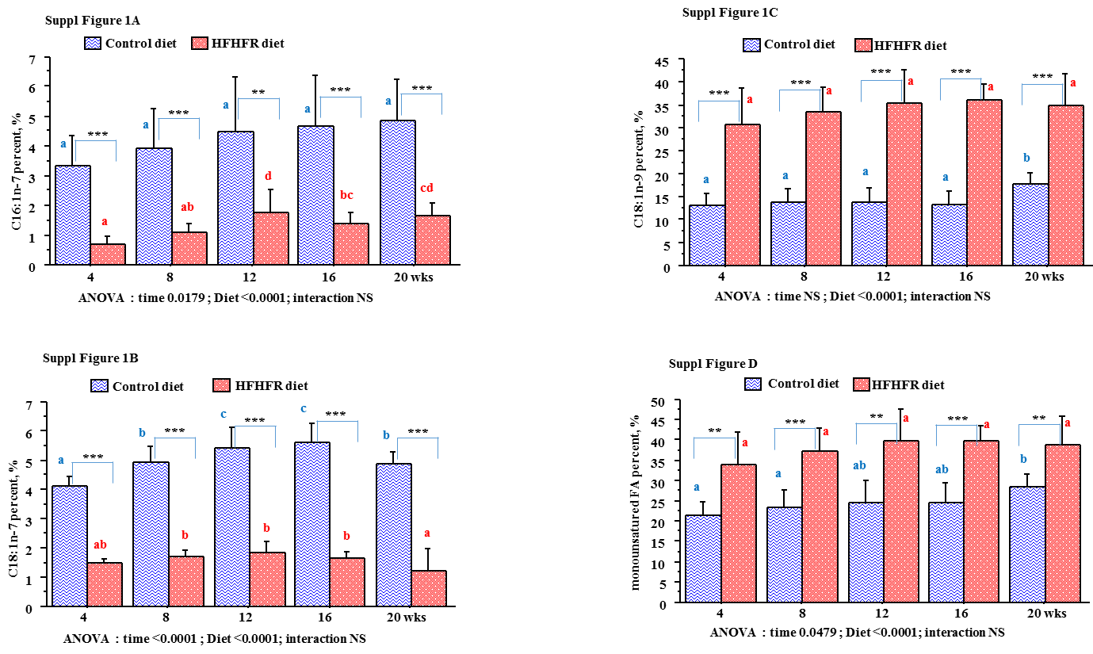
Supplementary Figure S1: Time-evolution of individual and total monounsaturated fatty acids in mitochondrial phospholipids in rats fed control or HFHFR diets for 4 to 20 weeks.
Results were expressed as means ± SD, n=6–8 animals per group per treatment duration. All the groups were tested for the effects of diet, treatment duration, and their interaction by two-way ANOVA test. When the effects of diet, treatment duration or their interaction were significant, one-way ANOVA test was applied to analyze the effect of treatment duration for each diet followed up by a Fisher's Least Significant Difference test, and the unpaired student’s t-test was used to analyze the effect of HFHFR diet within each treatment duration point. The limit of statistical significance was set at p<0.05. HFHFR diet vs control diet: *p<0.05, **p<0.005, ***p<0.0005. Inside the same diet, over treatment durations, the means with different letters (a, b, c, d, e) are significantly different.

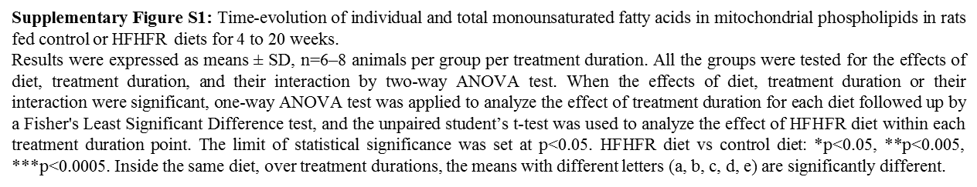
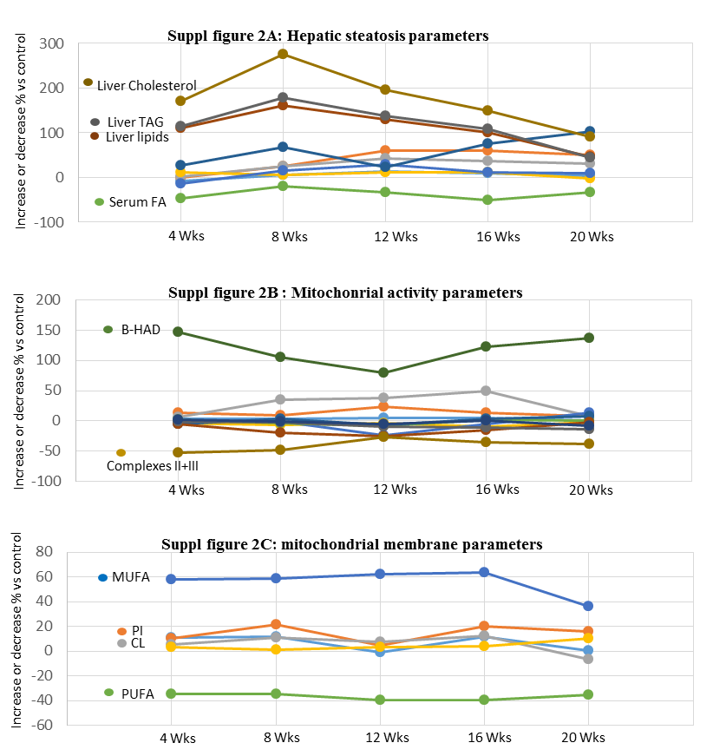

Supplementary Figure S2: The percent of time-evolution changes in hepatic steatosis and mitochondrial parameters in rats fed HFHFR diets for 4 to 20 weeks.
This graphic evolution of hepatic steatosis and mitochondrial parameters was drawn to facilitate the visual observation of installation and progression of hepatic steatosis in the high fat-high fructose diet-fed rats. It shows that these parameters evolve at the same time and thus it is difficult to say whether mitochondrial dysfunction precedes or follows the hepatic steatosis in rats fed HFHFR diets.
Supplementary Figure S2: The percent of time-evolution changes in hepatic steatosis and mitochondrial parameters in rats fed HFHFR diets for 4 to 20 weeks.
This graphic evolution of hepatic steatosis and mitochondrial parameters was drawn to facilitate the visual observation of installation and progression of hepatic steatosis in the high fat-high fructose diet-fed rats. It shows that these parameters evolve at the same time and thus it is difficult to say whether mitochondrial dysfunction precedes or follows the hepatic steatosis in rats fed HFHFR diets.
Supplementary Figure S1: Time-evolution of individual and total monounsaturated fatty acids in mitochondrial phospholipids in rats fed control or HFHFR diets for 4 to 20 weeks.
Results were expressed as means ± SD, n=6–8 animals per group per treatment duration. All the groups were tested for the effects of diet, treatment duration, and their interaction by two-way ANOVA test. When the effects of diet, treatment duration or their interaction were significant, one-way ANOVA test was applied to analyze the effect of treatment duration for each diet followed up by a Fisher's Least Significant Difference test, and the unpaired student’s t-test was used to analyze the effect of HFHFR diet within each treatment duration point. The limit of statistical significance was set at p<0.05. HFHFR diet vs control diet: *p<0.05, **p<0.005, ***p<0.0005. Inside the same diet, over treatment durations, the means with different letters (a, b, c, d, e) are significantly different.
Supplementary Figure S1: Time-evolution of individual and total monounsaturated fatty acids in mitochondrial phospholipids in rats fed control or HFHFR diets for 4 to 20 weeks.
Results were expressed as means ± SD, n=6–8 animals per group per treatment duration. All the groups were tested for the effects of diet, treatment duration, and their interaction by two-way ANOVA test. When the effects of diet, treatment duration or their interaction were significant, one-way ANOVA test was applied to analyze the effect of treatment duration for each diet followed up by a Fisher's Least Significant Difference test, and the unpaired student’s t-test was used to analyze the effect of HFHFR diet within each treatment duration point. The limit of statistical significance was set at p<0.05. HFHFR diet vs control diet: *p<0.05, **p<0.005, ***p<0.0005. Inside the same diet, over treatment durations, the means with different letters (a, b, c, d, e) are significantly different.

