Supplemental Figure 1: Unrooted tree comparing faecal phylotype composition in d0 and d28 samples from subjects (n = 26) fed placebo and β2-1 fructan. The d28 β2-1 fructan faecal sample is identified with a black circle. The faecal community composition of each subject is unique; feeding β2-1 fructan has minor effects on the faecal phylotype composition within each individual subject.

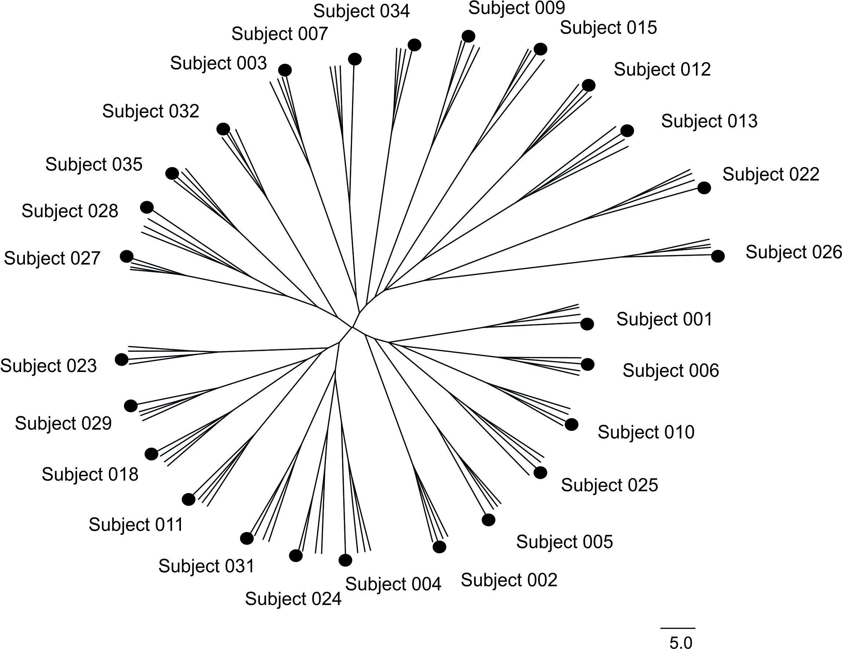

Supplemental Figure 2: (A) Linear and negative relationship between the content of Bacteroidetes and Firmicutes (% of total community; r = -0.838, P = 0.028). (B) Linear and positive relationship between Bacteroidetes content and faecal propionic acid concentration (r = 0.658, P = 0.011). Pearson correlations were corrected for false rate of discovery using a step down Bonferroni correction.
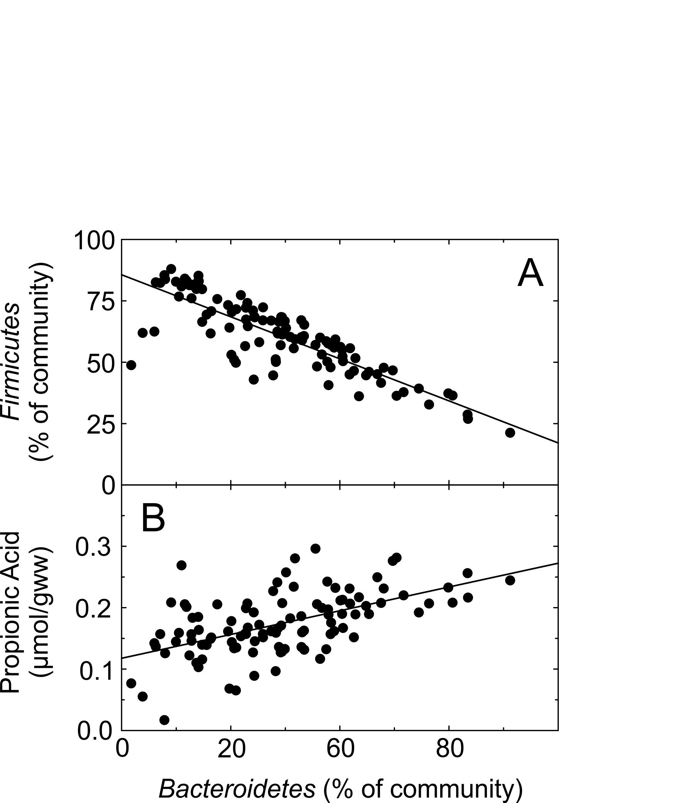

Supplemental Figure 3: Change in the content of family lineages in response to β2-1 fructan supplementation in four randomly selected subjects subjected to metagenomic analysis. Panel A: Subject 001. Panel B: Subject 006. Panel C: Subject 024. Panel D: Subject 025.

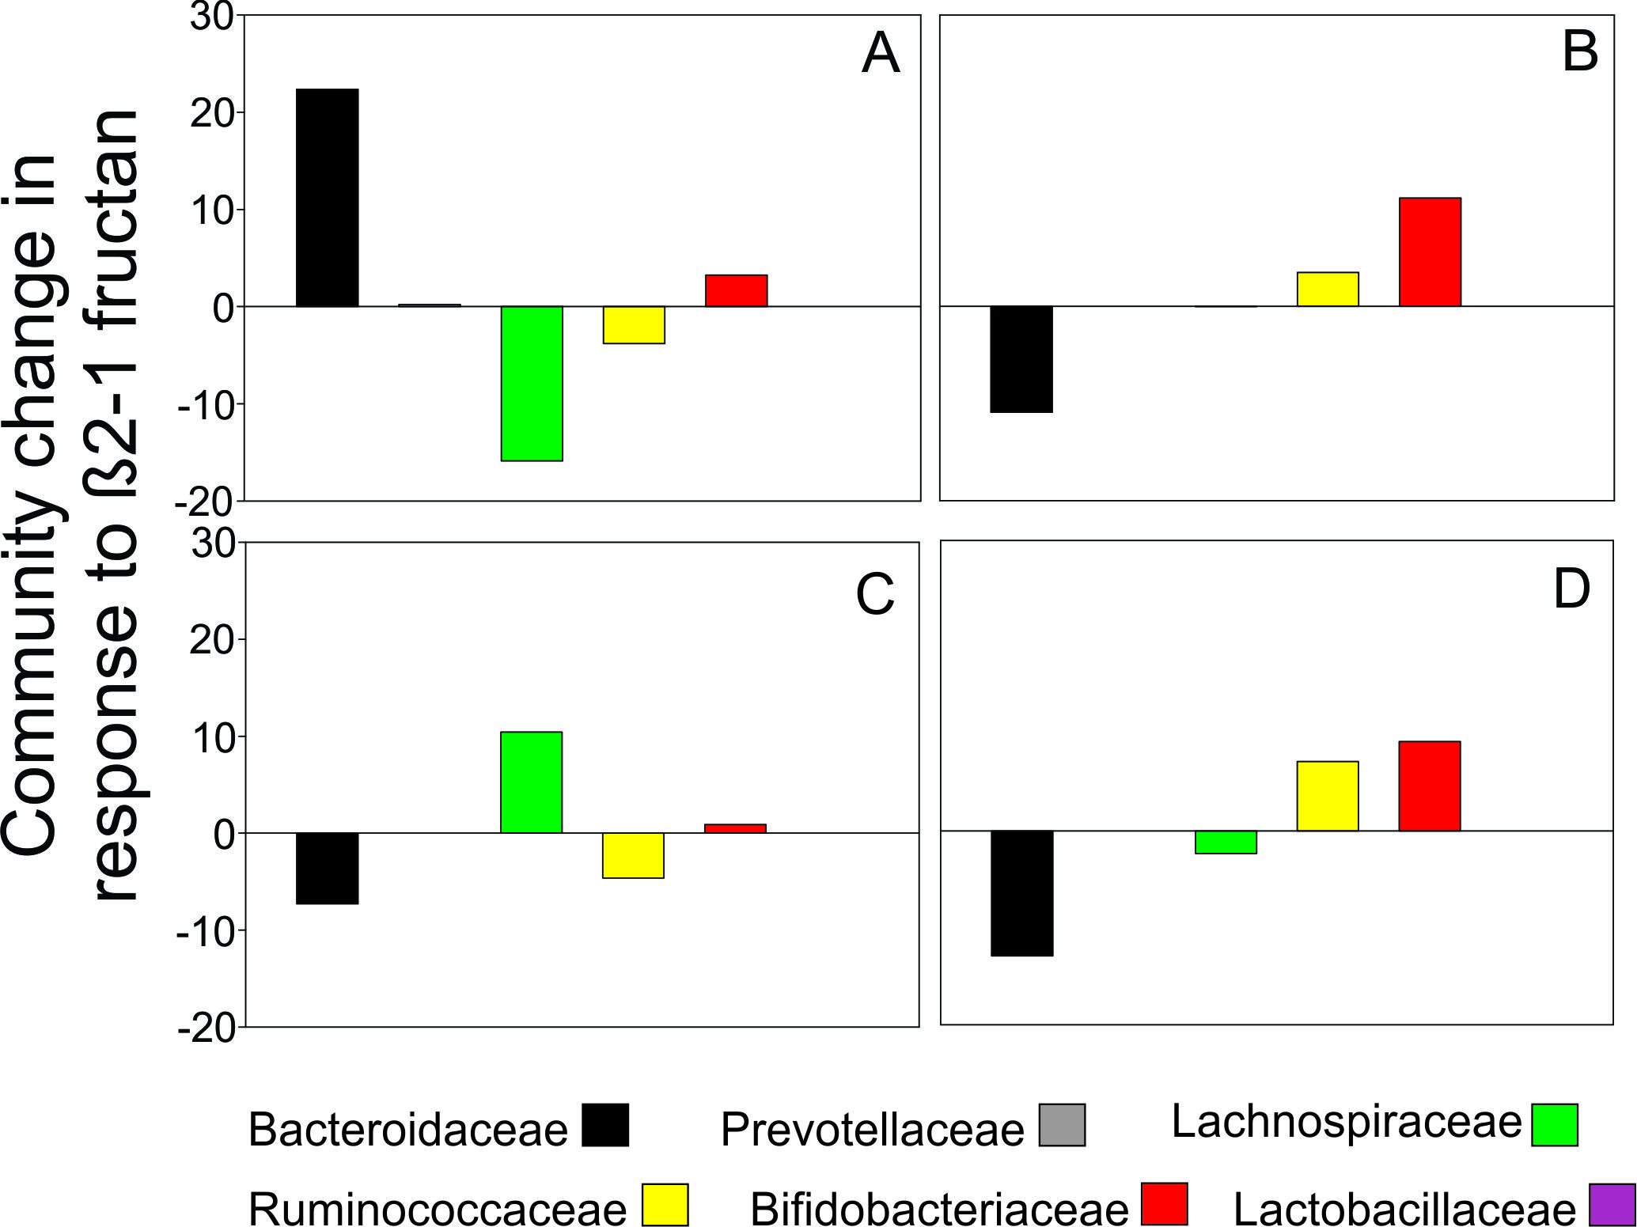

Supplemental Figure 4: Panel A: Comparison of gene assignments in the major SEED categories in the faecal communities of Subjects 1, 6, 24, and 25 over the course of the study. Panel B: Community composition of Subjects 1, 6, 24, and 25 at the family taxonomic level. P-placebo, F- β2-1 fructan.

