P HF < 0.0001
WG = 0.008
Time < 0.0001
Time x HF x WG = 0.0023

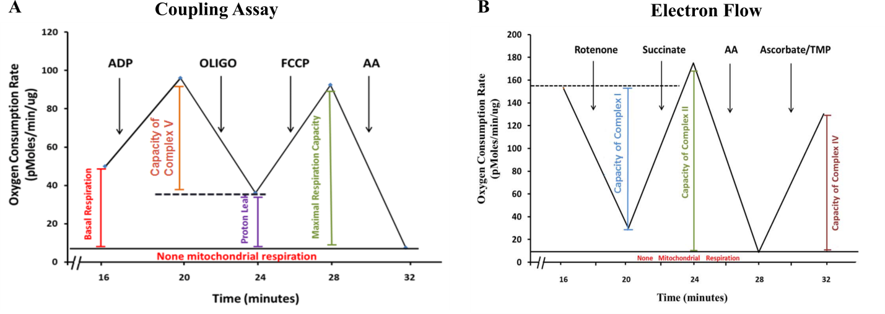
Supplementary Figure 1: Template for Seahorse XF^{e} 96 mitochondria respirometry analysis

Supplementary Figure 2: Serum concentrations of (a) Ghrelin, (b) Glucagon, (c) Leptin, (d) PAI-1 and (e) Resistin in C57BL/6 mice fed either a control (C) or high fat-high sucrose (HFS) diet supplemented with 10% wheat germ (WG) for 12 weeks. Results were obtained using the Bio-Plex MAGPIX Multiplex Reader and as part of the Bio-Rad kit (product # 171F7001M; Bio-Rad Laboratories, CA, USA) described in the methods section. Data = mean ± SE, n=9/group.
P values for significant main effects are shown in each panel. When the interaction HFS × WG was significant (P<0.05, two-way ANOVA), different letters indicate differences between groups as determined by the post-hoc testing. Dietary treatments: control (C), control + 10% wheat germ (C+WG), high fat-high sucrose (HFS), and high fat-high sucrose + 10% wheat germ (HFS+WG); PAI-1=plasminogen activator inhibitor 1.
Supplementary Table 1: Diet Composition (g/kg)
 | C | C+WG |  | HFS |  |  | HFS+WG
Wheat Germ (WG)¹ | -- | 100 | -- |  |  |  |  | 100
Carbohydrates
Total | 722.1 | 724.77 | 372.26 |  |  |  |  | 374.93
Cornstarch | 466 | 412.9 | 0 |  |  |  |  | 0
Sucrose | 100 | 100 | 270 |  |  |  |  | 270
Dextrinized Cornstarch | 155 | 155 | 100 |  |  |  |  | 46.9
WG¹ | -- | 53.1 | -- |  |  |  |  | 53.1
Protein
Total | 140 | 140 | 180 |  |  |  |  | 180
Casein | 140 | 116.6 | 180 |  |  |  |  | 156.6
WG¹ | -- | 23.4 | -- |  |  |  |  | 23.4
Fat
Total | 40 | 40 | 350 |  |  |  |  | 350
Soybean Oil | 40 | 33.35 | 40 |  |  |  |  | 33.35
Lard | 0 | 0 | 310 |  |  |  |  | 310
WG¹ | -- | 6.65 | -- |  |  |  |  | 6.65
Fiber
Total | 50 | 50 | 50 |  |  |  |  | 50
Cellulose | 50 | 45.84 | 50 |  |  |  |  | 45.84
WG¹ | -- | 4.16 | -- |  |  |  |  | 4.16
Vitamin Mix² | 10 | 10 | 10 |  |  |  |  | 10
Mineral Mix³
Total | 35 | 35 | 35 |  |  |  |  | 35
Calcium | 25.9 | 25.7 | 25.9 |  |  |  |  | 25.7
Calcium from WG¹ | -- | 0.06 | -- |  |  |  |  | 0.06
Sodium Phosphate | 5.6 | 3.8 | 4.8 |  |  |  |  | 3.02
Potassium Phosphate | 2.4 | 1.65 | 2.06 |  |  |  |  | 1.3
Phosphorous from WG¹ | -- | 0.8 | -- |  |  |  |  | 0.8
Sucrose | 1.1 | 3.76 | 2.3 |  |  |  |  | 4.92
Kcal/g | 3.8 | 3.8 | 5.4 |  |  |  |  | 5.4

¹Wheat germ composition (Shawnee Mills, OK, USA) was analyzed by NP Analytical Laboratory (St. Louis, MO, USA): carbohydrates, 53.1%; protein, 23.4%; fat, 6.65%; fiber, 4.16%; calcium, 0.06%; and phosphorus, 0.08%.
²Harlan-Teklad Laboratories (TD 94047, WI, USA).
³Complete mineral mix (TD94049, Harlan-Teklad Laboratories) was used for the control diet (C) and a calcium and phosphorus deficient mineral mix (TD 98057, Harlan-Teklad Laboratories) was used for the C+WG and the HFS diets.
C=Control; C+WG= Control + 10% Wheat Germ; HFS=High Fat-High Sugar; HFS+WG=High Fat-High Sugar + 10% Wheat Germ

Supplementary Table 2: Oligonucleotide Primers for RT-PCR
Target gene | Primer Sequence
Pgc1α | F 5’ AAC-CAC-ACC-CAC-AGG-ATC-AGA 3’  R 5’ TCT-TCG-CTT-TAT-TGC-TCC-ATG-A 3’
Pgc1β | F 5’ GAG-GGC-TCC-GGC-ACT-TC 3’  R 5’ CGT-ACT-TGC-TTT-TCC-CAG-ATG-A 3’
Sod1 | F 5’ GCC-CGG-CGG-ATG-AAG-A 3’  R 5’ CGT-CCT-TTC-CAG-CAG-TCA-CA 3’
Sod2 | F 5’ CTC-TGG-CCA-AGG-GGA-GAT-GTT 3’  R 5’ GTC-CCC-CAC-CAT-TGA-ACT-TC 3’
Sod3 | F 5’ CAG-ACA-AAG-GAG-CGC-AAG-AAG 3’  R 5’ TGA-GGC-TTA-AGT-GGT-CTT-GCA 3’

