Supplemental Table S1: Mitochondrial adaptations evaluated via O₂ consumption induced by pyruvate/malate/glutamate (PMG) in adult mice liver (pmol O₂/mg of protein * sec)
Groups | Control  diet | Trans-fat  diet | Palm oil  diet | Interesterified  fat diet
OXPHOS capacity | 1378.7 ± 227.6 | 971.7 ± 215.9 | 1065.5 ± 235.6 | 1067.9 ± 200.3
ETS capacity | 1851.3 ± 312.5 ª | 822.2 ± 54.7 ^{b} | 1461.9 ± 259.0 ^{ab} | 1568.4 ± 316.2 ^{ab}
Leak respiration | 186.3 ± 31.0 | 122.9 ± 16.9 | 167.0 ± 30.9 | 176.9 ± 36.3
Coupled respiration | 1141.1 ± 194.4 | 815.9 ± 201.1 | 848.9 ± 202.3 | 840.7 ± 158.9
Non-p-state after PMG | 286.4 ± 36.0 | 193.0 ± 28.0 | 277.9 ± 47.0 | 269.6 ± 42.0
Maximal respiration  (coupled) | 1307.7 ± 186.8 | 776.0 ± 129.1 | 975.1 ± 215. 5 | 1050.5 ± 200.3
Oligo respiration | 237.5 ± 35.1 | 155.8 ± 15.4 | 205.6 ± 36.5 | 227.2 ± 43.5
ATP synthesis (O2 flow coupled to ATP - - O2 flow with Oligo | 1070.1 ± 152.8 | 620.1 ± 114.4 | 769.5 ± 180.1 | 823.3 ± 158.4
Coupled respiratory control (O2 flow ADP/O2 flow Oligo) | 5.6 ± 0.2 | 4.8 ± 0.3 | 4.6 ± 0.2 | 4.6 ± 0.2
Complex I | 1333.5 ± 201.0 ª | 717.5 ± 54.8 ^{b} | 1026.9 ± 156.5 ª | 917.4 ± 128.6 ª
ROX (ANT A) | 51.2 ± 6.6 | 32.9 ± 5.8 | 38.6 ± 6.4 | 50.3 ± 7.8
The number of individual experiments is shown in parentheses. PMG: pyruvate/malate/glutamate; Oligo: Olimycin; ROX: residual oxygen consumption; ANT A: antimicyn A; OXPHOS: oxidative phosphorylation; ETS: electron transfer system. The data are expressed in Mean ± SEM. a,b, different superscript letters shows significantly difference between experimental groups (P<0.05 ANOVA, with Newman-Keuls post hoc test). (n=7-8).

Supplemental Table S2: Mitochondrial adaptations evaluated via O₂ consumption induced by succinate (SUCC) in adult mice liver (pmol O₂/mg of protein * sec)
Groups | Control  diet | Trans-fat  diet | Palm oil  diet | Interesterified  fat diet
OXPHOS | 1979.2 ± 213.1 | 1271.1 ± 96.0 | 1923.8 ± 334.0 | 1678.0 ± 242.4
ETS capacity | 1952.8 ± 472.9^{ab} | 1108.0 ± 243.3 ^{b} | 2195.8 ± 400.6 ª | 1651.5 ± 313.5 ^{ab}
Leak respiration | 377.1 ± 72.8 | 212.9 ± 45.5 | 390.5 ± 59.2 | 428.01 ± 80.6
Coupled respiration | 1575.3 ± 192.4 | 1035.8 ± 75.6 | 1508.4 ± 288.5 | 1216.6 ± 162.2
Non-p-state after SUCC | 655.8 ± 77.4 ª | 379.0 ± 31.2 ^{b} | 570.1 ± 253.1 ª | 573.0 ± 86.3 ª
Maximal respiration  (coupled) | 1890.6 ± 225.4^{ab} | 1160.1 ± 86.0 ^{c} | 1751.1 ± 297.2 ^{ab} | 1591.1± 246.2^{abc}
Oligo respiration | 403.9 ± 74.3 | 235.3 ± 47.2 | 415.4 ± 61.9 | 461.3 ± 84.0
ATP synthesis (O₂  flow coupled to ATP - - O₂ flow with Oligo | 1487.0 ± 196.4 ª | 925.21 ± 68.6 ^{b} | 1335.7 ± 243.3 ª | 1129.7 ± 168.7 ª
Coupled respiratory control (O₂ flow ADP/O2 flow Oligo) | 5.31 ± 0.6 | 5.03 ± 0.6 | 4.17 ± 0.3 | 3.68 ± 0.4
Proton leak | 377.1 ± 72.8 | 212.9 ± 45.5 | 390.5 ± 59.2 | 428.01 ± 80.6
Complex II | 1291.5 ± 296.0 | 930.9 ± 245.6 | 1445.6 ± 298.5 | 1149 ± 265.8
ROX (ANT A) | 26.9 ± 5.0 | 22.4 ± 2.5 | 24.9 ± 3.9 | 33.3 ± 4.0
The number of individual experiments is shown in parentheses. SUCC: succinate; Oligo: Olimycin ROX: residual oxygen consumption; ANT A: antimicyn A; OXPHOS: oxidative phosphorylation; ETS: electron transfer system. The data are expressed in Mean ± SEM. a,b, different superscript letters shows significantly difference between experimental groups (P<0.05 ANOVA, with Newman-Keuls post hoc test). (n=7-8).

Supplemental Figure S1
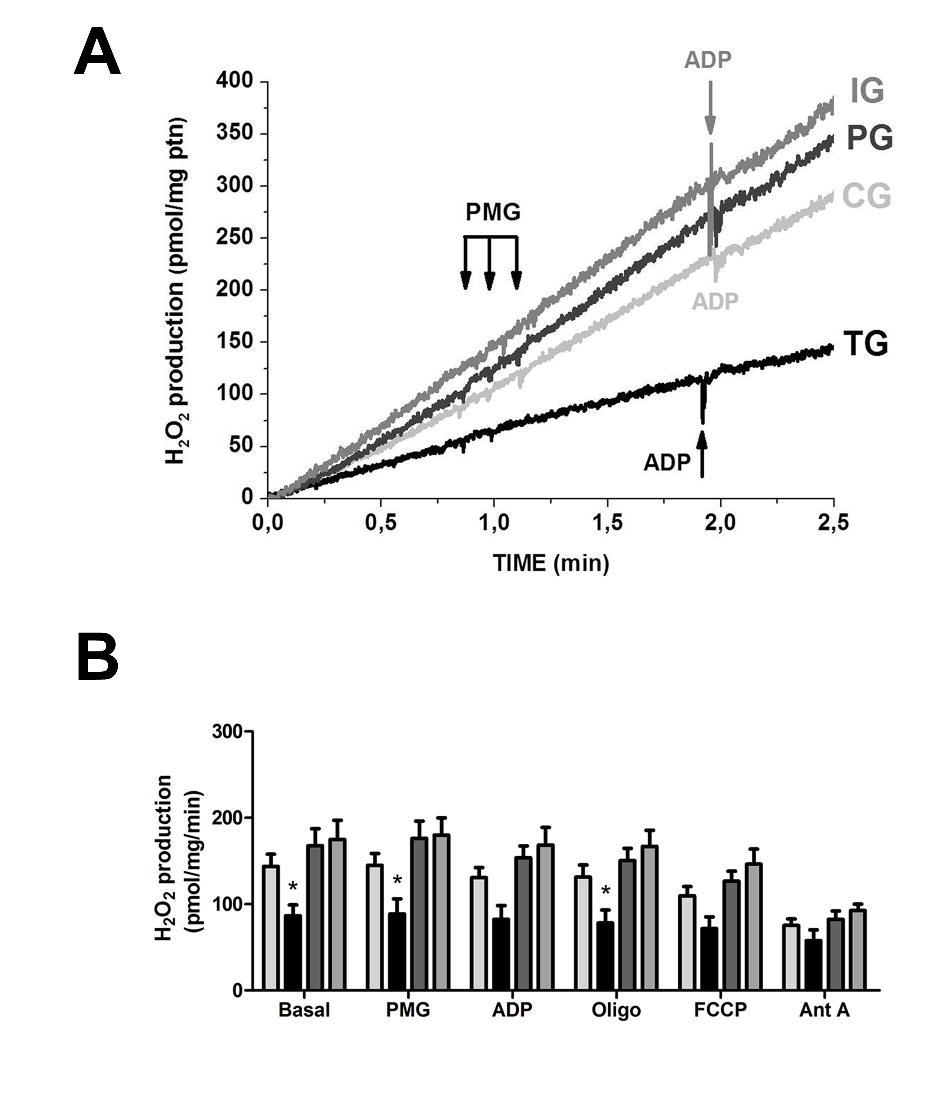
Hydrogen peroxide (H₂O₂) production using multiple titrations. H₂O₂ rates were measured after complex I stimulation (pyruvate/malate/glutamate - PMG). (A) Representative graph demonstrate that after PMG were observed no differences in H₂O₂ production in IG, PG and CG. (B) Quantitative results indicate that levels of H₂O₂ did not change throughout sequential addition. However, statistical data showed that TG presented reduced H₂O₂ production even under basal condition. The experiments were done with sequential addition of substrates from complex I (pyruvate/malate/glutamate, 2 mM each), followed by 0.5 mM ADP, 2 µg/mL oligomycin, 0.5 µM FCCP, 5 µM antimycin A. The data are expressed as the mean ± standard error. *p<0.05 (n=7-8).

