Supplementary table 1. Predominant bacterial species (expressed as a percentage of total sequences) in faeces of dogs fed diets containing graded potato fibre (PF) concentrations§
 | % PF
Species | 0 | 1·5 | 3 | 4·5 |  | 6 | SEM | P-Value
Bifidobacterium pseudolongum | 0·21^{ab} | 0·24^{ab} | 0·15^{ab} | 0·50^{b} | 0·09ª |  | 0·17 | 0·04
Prevotella copri‡ | 0·68^{b} | 0·24ª | 0·40^{ab} | 0·52^{ab} | 0·22ª |  | 0·36 | 0·02
Clostridium bifermentans | 0·40 | 0·37 | 0·56 | 0·75 | 0·40 |  | 0·27 | 0·59
C. citroniae‡* | 0·06 | 0·09 | 0·15 | 0·17 | 0·15 |  | 0·03 | 0·05
C. disporicum | 0·01 | 0·02 | 0·02 | 0·03 | 0·03 |  | 0·01 | 0·89
C. hiranonis* | 19·57^{b} | 16·64^{ab} | 19·64^{b} | 19·29^{b} | 10·42ª |  | 4·37 | 0·02
C. incertae sedis† | 0·18 | 0·37 | 0·33 | 0·48 | 0·14 |  | 0·17 | 0·18
C. lactatifermen† | 0·01 | 0·06 | 0·06 | 0·11 | 0·02 |  | 0·03 | 0·12
C. metallolevans | 0·03 | 0·05 | 0·08 | 0·07 | 0·04 |  | 0·03 | 0·39
C. spiroforme | 0·42 | 0·36 | 0·52 | 0·22 | 0·21 |  | 0·14 | 0·25
Allobaculum stercoricanis#† | 2·51 | 3·42 | 3·83 | 2·72 | 2·45 |  | 0·84 | 0·16
Catenibacterium mitsuokai | 0·13 | 0·11 | 0·06 | 0·06 | 0·03 |  | 0·05 | 0·64
Coprobacillus cateniformis | 0·12 | 0·15 | 0·16 | 0·15 | 0·11 |  | 0·04 | 0·86
Turicibacter sanguinis | 0·70 | 0·55 | 0·77 | 0·80 | 0·55 |  | 0·23 | 0·62
Eubacterium biforme | 0·20 | 0·35 | 0·29 | 0·46 | 0·34 |  | 0·15 | 0·62
E. dolichum | 0·15 | 0·18 | 0·10 | 0·09 | 0·04 |  | 0·06 | 0·24
Blautia producta† | 6·33 | 7·81 | 7·61 | 7·56 | 5·98 |  | 1·34 | 0·31
Ruminococcus obeum | 1·29^{ab} | 0·81ª | 1·44^{ab} | 2·32^{b} | 0·97^{ab} |  | 0·51 | 0·03
R. gnavus | 1·04 | 0·94 | 0·83 | 1·06 | 0·60 |  | 0·38 | 0·38
R. torques | 0·33 | 0·32 | 0·52 | 0·35 | 0·49 |  | 0·18 | 0·84
Lactobacillus acidophilus | 0·11 | 0·05 | 0·09 | 0·07 | 0·09 |  | 0·07 | 0·96
L. johnsonii | 0·68 | 3·54 | 0·66 | 2·04 | 3·45 |  | 1·82 | 0·62
L. reuteri (strain F275) | 0·19 | 0·68 | 0·17 | 0·54 | 0·53 |  | 0·34 | 0·72
Faecalibacterium prausnitzii‡* | 4·15ª | 8·67ª | 8·89ª | 9·63ª | 14·88^{b} |  | 2·00 | 0·01
Lactococcus lactis lactis | 0·14 | 0·46 | 0·05 | 0·12 | 0·01 |  | 0·16 | 0·36
Fusobacterium varium | 15·51 | 16·77 | 14·21 | 12·34 | 18·35 |  | 2·76 | 0·22
§Genera included have LSMEANs of 0·01 or higher.
^{ab}Means in the same row with unlike superscript letters differ (P < 0·05).
‡ Difference between 0% PF vs. all other PF diets (P < 0·05).
*Linear effect (P < 0·05).
†Quadratic effect (P < 0·05).

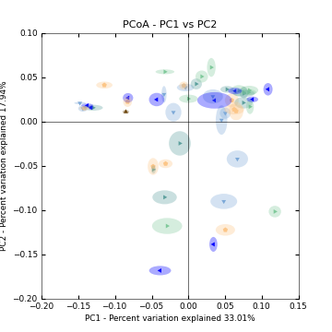
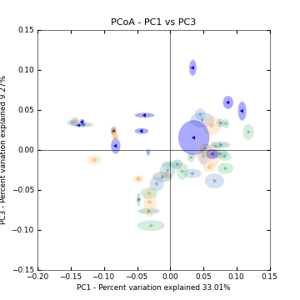

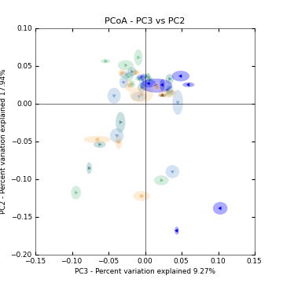

Supplementary figure 1: PCoA plots of faecal samples collected from dogs fed diets containing graded potato fibre (PF) concentrations. Violet: 0% PF; green: 1.5% PF; light blue 3% PF; orange: 4.5% PF; light green: 6% PF.

Supplementary figure 2. E. coli and C. Perfringens scatter plots for qPCR data. Horizontal line denotes the median value.

