Supplemental data
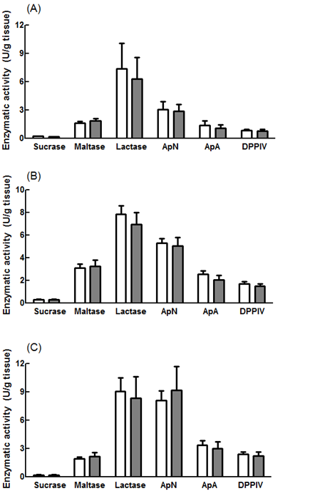
Supplemental Figure 1. Activity of brush border enzymes: sucrose, lactase, maltase, aminopeptidases A (ApA) and N (ApN) and dipeptidylpeptidase IV (DPPIV) obtained in three regions proximal (A), middle (B), distal (C) of small intestine. , CON pigs; , LF pigs. Values are means ± SEM. * P<0.05.

